Guitar Heroine

This assignment was originally developed by Kevin Wayne at Princeton University (here is the link to the original assignment).

Write a program to simulate plucking a guitar string using the Karplus-Strong algorithm. This algorithm played a seminal role in the emergence of physically modeled sound synthesis (where a physical description of a musical instrument is used to synthesize sound electronically).
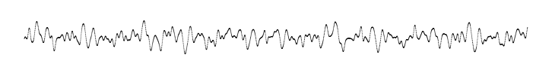
Simulate the plucking of a guitar string. When a guitar string is plucked, the string vibrates and creates sound. The length of the string determines its fundamental frequency of vibration. We model a guitar string by sampling its displacement (a real number between -1/2 and +1/2) at N equally spaced points (in time), where N equals the sampling rate (44,100) divided by the fundamental frequency (rounding the quotient up to the nearest integer).
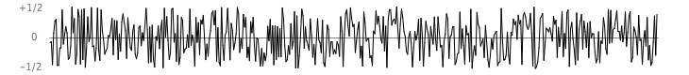
- Plucking the string. The excitation of the string can contain energy at any frequency. We simulate the excitation with white noise: set each of the N displacements to a random real number between -1/2 and +1/2.
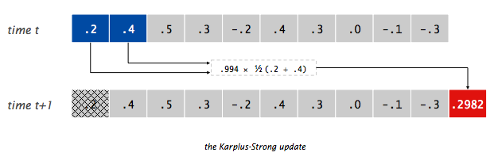
- The resulting vibrations. After the string is plucked, the string vibrates. The pluck causes a displacement which spreads wave-like over time. The Karplus-Strong algorithm simulates this vibration by maintaining a ring buffer of the N samples: the algorithm repeatedly deletes the first sample from the buffer and adds to the end of the buffer the average of the first two samples, scaled by an energy decay factor of 0.994.

Why it works? The two primary components that make the Karplus-Strong algorithm work are the ring buffer feedback mechanism and the averaging operation.
- The ring buffer feedback mechanism. The ring buffer models the medium (a string tied down at both ends) in which the energy travels back and forth. The length of the ring buffer determines the fundamental frequency of the resulting sound. Sonically, the feedback mechanism reinforces only the fundamental frequency and its harmonics (frequencies at integer multiples of the fundamental). The energy decay factor (.994 in this case) models the slight dissipation in energy as the wave makes a roundtrip through the string.
- The averaging operation. The averaging operation serves as a gentle low-pass filter (which removes higher frequencies while allowing lower frequencies to pass, hence the name). Because it is in the path of the feedback, this has the effect of gradually attenuating the higher harmonics while keeping the lower ones, which corresponds closely with how a plucked guitar string sounds.
From a mathematical physics viewpoint, the Karplus-Strong algorithm approximately solves the 1D wave equation, which describes the transverse motion of the string as a function of time.
Ring buffer. Your first task is to create a data type to model the ring buffer. Complete the RingBuffer class that implements the following API:
public class RingBuffer
------------------------------------------------------------------------
RingBuffer(int capacity) // create an empty ring buffer,
// with given capacity
int size() // return number of items in buffer
boolean isEmpty() // is the buffer empty
boolean isFull() // is the buffer full
void add(double x) // add item x to the end
double peek() // return (but do not delete) item
// from the front
double remove() // delete and return item from the
// front

Since the ring buffer has a known maximum capacity, implement it using a double array of that length. For efficiency, use cyclic wrap-around: Maintain one integer instance variable front that stores the index of the least recently inserted item; maintain a second integer instance variable rear that stores the index one beyond the most recently inserted item. To insert an item, put it at index rear and increment rear. To remove an item, take it from index front and increment front. When either index equals capacity, make it wrap-around by changing the index to 0.
Implement RingBuffer to throw an exception if the client attempts to remove from an empty buffer or add into a full buffer.
You should test your RingBuffer data type by invoking the provided main method. It will add the numbers 1 through 100, and then repeatedly remove the first two, and add their sum. If it is working properly, you will get the following results.
Size after wrap-around is 100
5050.0
Make sure RingBuffer is working properly before proceeding any further.
Guitar string. Next, create a data type to model a vibrating guitar string. Complete the GuitarString class that implements the following API:
public class GuitarString
------------------------------------------------------------------------
GuitarString(double frequency) // create a guitar string of the
// given frequency, using a
// sampling rate of 44,100
GuitarString(double[] array) // create a guitar string whose
// size and initial values are
// given by the array
void pluck() // set the buffer to white noise
void tic() // advance one time step
double sample() // return the current sample
int time() // return number of tics
- Constructors. There are two ways to create a GuitarString object.
  - The first constructor creates a RingBuffer of the desired capacity N (sampling rate 44,100 divided by frequency, rounded up to the nearest integer), and initializes it to represent a guitar string at rest by enqueueing N zeros.
  - The second constructor creates a RingBuffer of capacity equal to the size of the array, and initializes the contents of the buffer to the values in the array. On this assignment, its main purpose is for debugging and grading.
- Pluck. Replace the N items in the ring buffer with N random values between -0.5 and +0.5.
- Tic. Apply the Karplus-Strong update: delete the sample at the front of the ring buffer and add to the end of the ring buffer the average of the first two samples, multiplied by the energy decay factor.
- Sample. Return the value of the item at the front of the ring buffer.
- Time. Return the total number of times tic() was called.
You should test your GuitarString data type by invoking the provided main method. It will create a GuitarString object and load it with an array of values, and display some of the string vibration iterations. If it is working properly, you will get the following results.

0 0.2000
1 0.4000
2 0.5000
3 0.3000
4 -0.2000
5 0.4000
6 0.3000
7 0.0000
8 -0.1000
9 -0.3000
10 0.2988
11 0.4482
12 0.3984
13 0.0498
14 0.0996
15 0.3486
16 0.1494
17 -0.0498
18 -0.1992
19 -0.0006
20 0.3720
21 0.4216
22 0.2232
23 0.0744
24 0.2232

Make sure GuitarString is working properly before proceeding any further.
Interactive guitar player. GuitarHeroLite is a sample GuitarString client that plays the guitar in real-time, using the keyboard to input notes. When the user types the lowercase letter 'a' or 'c', the program plucks the corresponding string. Since the combined result of several sound waves is the superposition of the individual sound waves, we play the sum of all string samples.
Run GuitarHeroLite to make sure that you can hear the two strings play clearly on your computer speakers.
Then, complete the assignment by writing a GuitarHero class that is similar to GuitarHeroLite, but supports a total of 37 notes on the chromatic scale from 110Hz to 880Hz. In general, make the ith character of the string below play the i note.

String keyboard = "q2we4r5ty7u8i9op-[=zxdcfvgbnjmk,.;/' ";
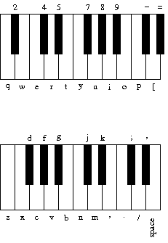
This keyboard arrangement imitates a piano keyboard: The "white keys" are on the qwerty and zxcv rows and the "black keys" on the 12345 and asdf rows of the keyboard.

The ith character of the string corresponds to a frequency of 440 × 1.05956^{(i - 24)}, so that the character 'q' is approximately 110Hz, 'i' is close to 220Hz, 'v' is close to 440Hz, and ' ' is close to 880Hz. Create an array of 37 GuitarString objects and use keyboard.indexOf(key) to figure out which key was typed. Make sure your program does not crash if a key is played that is not one of your 37 notes.
Remember that the combined result of several sound waves is the superposition of the individual sound waves, so you will want to be sure to play the sum of all the string samples.

Finally, demonstrate your work by entering the following keystrokes into your guitar to get the beginning of Led Zeppelin's Stairway to Heaven. Multiple notes in a column are dyads and chords.
w q q
8 u 7 y o p p
i p z v b z p b n z p n d [ i d z p i p z p i u i i
What is this familiar melody?
nn//SS/ ..,,mmn //..,,m //..,,m nn//SS/ ..,,mmn (S = space)
Are you able to play another song of your choice?
Challenge Modify the Karplus-Strong algorithm to synthesize a different instrument. Consider changing the excitation of the string (from white-noise to something more structured) or changing the averaging formula (from the average of the first two samples to a more complicated rule) or anything else you might imagine.

